WRITING A LETTER

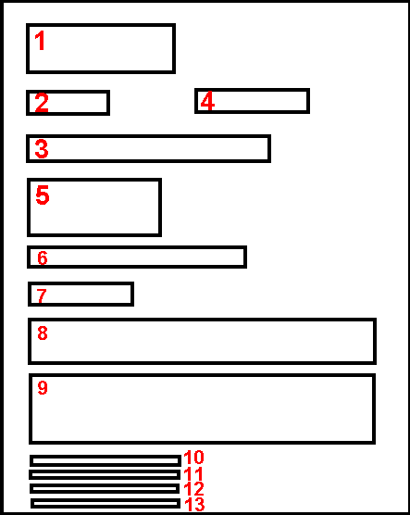
1 = sender
2 = references
3 = optional: 'Private and confidential' for confidential documents
4 = date: September, 10th 2008
5 = recipient
6 =Attention: The Manager / Mr. / Mrs. / Ms.
7 = Dear Sirs / Dear Mr. / Dear Mrs. / Dear Ms.
8 = main object
9 = body
10 = 'Yours faithfully / Yours sincerely'.
11 = Signature
12 = your name
13 = optional
'Encl.' (enclosed) if you've enclosed documents
'copy to' if you've sent this letter to several people

USEFUL IDOMS
Being polite:
- You've already met the recipient
Starting: Dear Mr. Simpson,
End: Yours sincerely (more friendly): With all good wishes, (or) With kindest regards,
- You are writing to a relative
Starting: Dear Victoria, My dear Victoria, Dear Aunt Victoria, Dearest Victoria, My dearest Victoria, My darling Victoria,
End: With love from Sandra Love from Sandra (more familiar) Love to all Love from us all Yours All the best (encore plus affectueux) With much love from Sandra Lots of love from Sandra Much love, as always All my love
- You are writing a business letter
Start: -> you are writing to a company: Dear Sirs, -> you are writing to a man: Dear Sir, -> you are writing to a woman: Dear Madam, -> you don't know if the recipient is a man or a woman: Dear Sir or Madam,
End: Yours faithfully
- You are writing to a friend
Start: Dear Victoria, My dear Victoria;
End: Yours sincerely With best wishes, Best wishes, With kindest regards, Kindest regards, All good wishes,
Other useful idioms...
WRITING A LETTER
15th April 2003
Dear Sir/Dear Sirs
Dear Mr (Mrs) Smith
Dear Jenny,
Thank you for your letter.
It was kind of you to write to me.
I got your lovely letter.
I am writing to inform you that...
I am writing to confirm my telephone call.
Following our telephone conversation...
I'm sorry I haven't written before.
I am sorry I cannot accept your invitation.
I shall be arriving at 6 pm.
We'll be at the airport to meet you.
Let me know which train you'll be on.
Thank you very much for having me to stay.
I had a really good holiday.
I enclose a stamped addressed envelope.
Could you let us have it by return of post?
Please give my best wishes to Tim.
Say hello to Sandra for me.
Tell Mike I was asking after him.
John and I send you our very best wishes.
Mike has asked me to say that...
Give my love to the rest of the family.
Must go now.
Love from Sandra
Much love from Peter.
See you on Sunday, Yours, Sandra
Yours faithfully,
Looking forward to seeing you soon,
Yours sincerely,

